Experiment – 1

Name: Velchuri Sarvan

ID: CH.EN.U4CSE22160

**Aim:**

To compile the lex programs using the lex compiler and execute it using GCC compiler

1. Program to count the number of vowels and consonants in a given string.

2. Program to count the number of characters, words, spaces, end of lines in a given input file.

3. Program to count no of:  
a) +ve and –ve integers  
b) +ve and –ve fractions

4. Program to count the no of comment line in a given C program. Also eliminate them and copy that program into separate file

5. Program to count the no of ‘scanf' and ‘printf' statements in a C program. Replace them with ‘readf' and ‘writef' statements respectively.

**Algorithm and procedure:**

1. Save the code with .l extension.  
2. Run the code ( lex <filename>.l ).

3. This will create an output file with the extension .yy.c which can be executed using the gcc compiler

4. Now run the command ( gcc <filename>.yy.c ).

5. This will generate an exe file as usual

6. Run the exe file with the command ( ./a.out <by default> ) and the program will be executed successfully in the output terminal

Programs:

1.

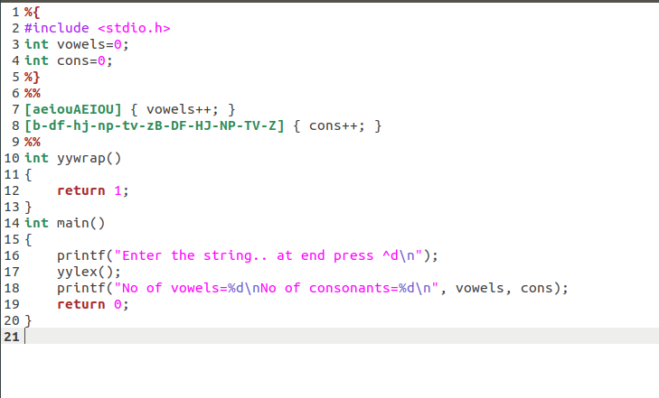

2.

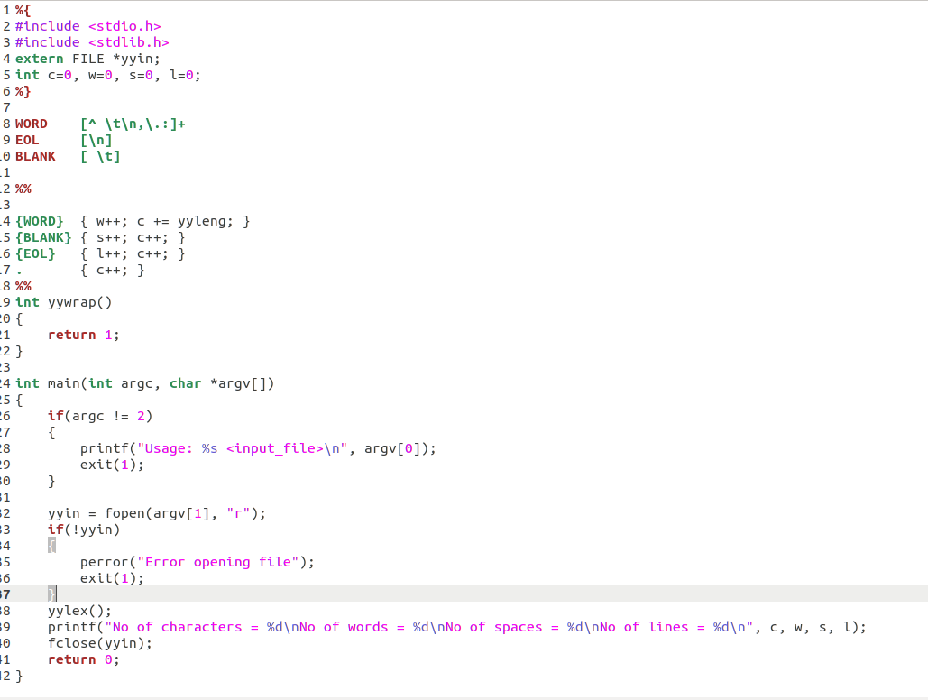

3.

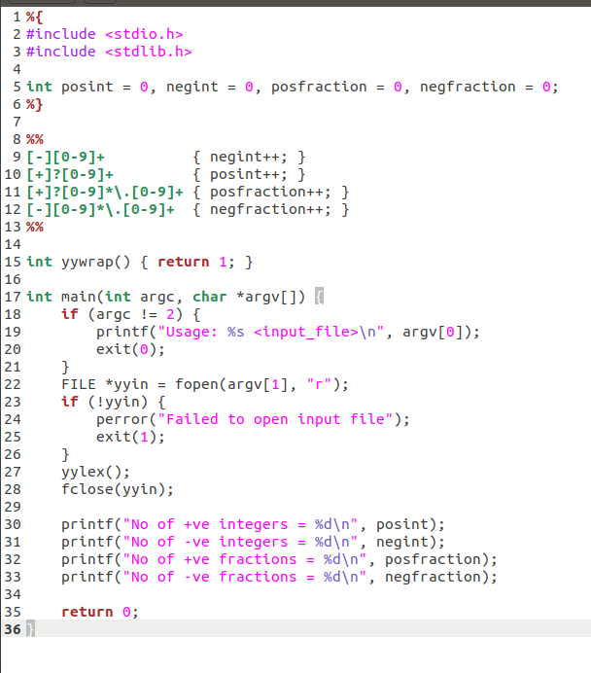

4.

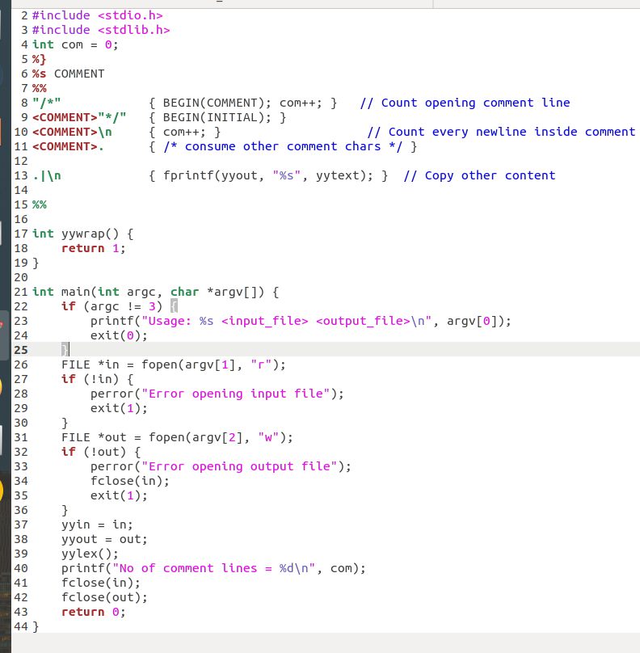

5)

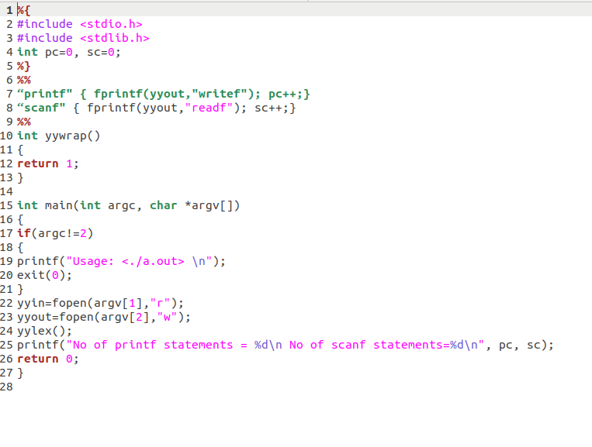

**Output:**

1.

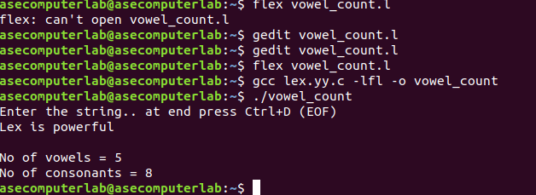2.

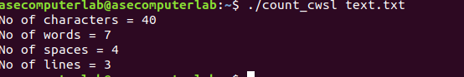

3.

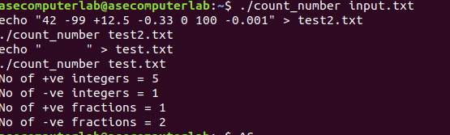



4.

